Test Case: tc002_SPX_Dev5_Crear_Requisicion_Spot_Tipo_Cobro_Project
Step 1 - Enter username and password and click to button Enter: Credentials Entered
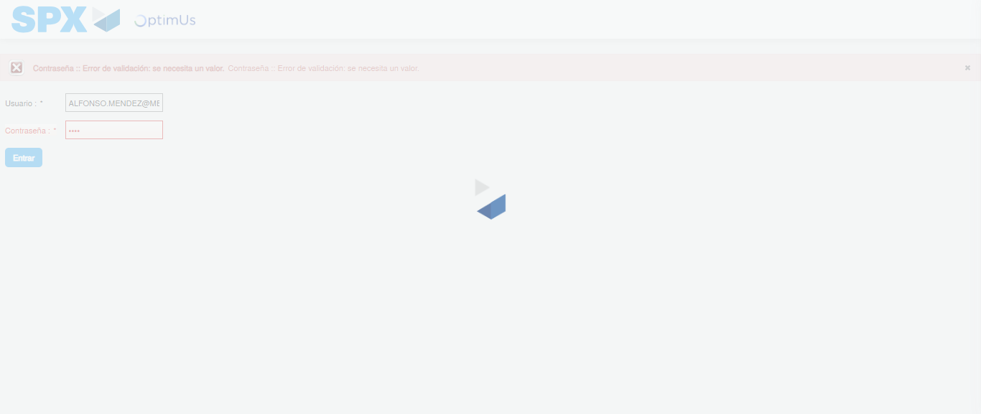Image file-name: QC_Testing-tc002_SPX_Dev5_Crear_Requisicion_Spot_Tipo_Cobro_Project-1784308152551

Step 2 - Select to UEN and Access to Spot Buy Requisitions : UEN Correctly selected and Correct access
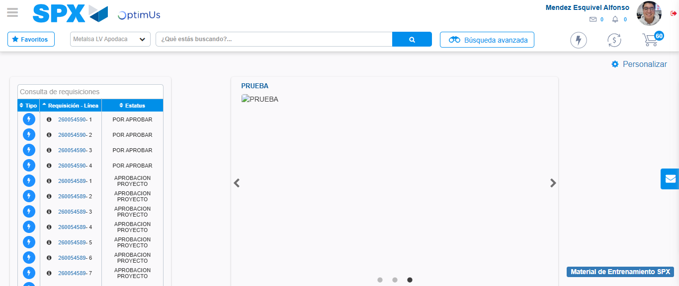Image file-name: QC_Testing-tc002_SPX_Dev5_Crear_Requisicion_Spot_Tipo_Cobro_Project-1784308224220

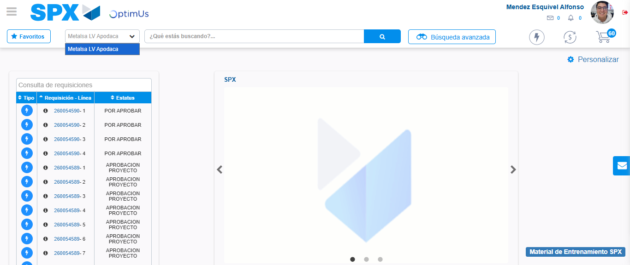Image file-name: QC_Testing-tc002_SPX_Dev5_Crear_Requisicion_Spot_Tipo_Cobro_Project-1784308226726

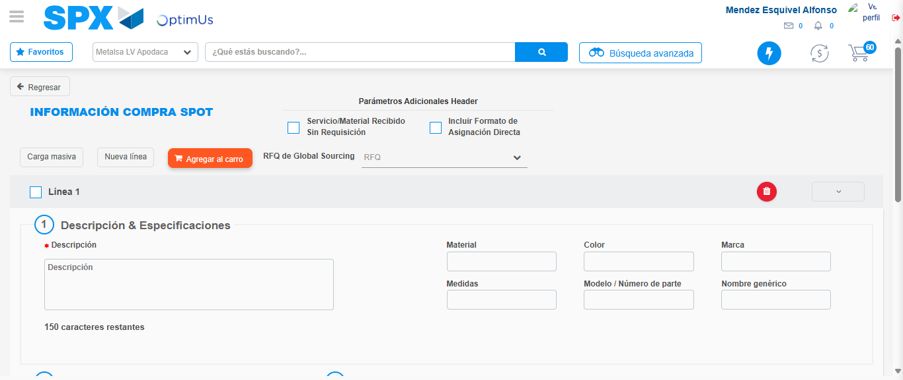Image file-name: QC_Testing-tc002_SPX_Dev5_Crear_Requisicion_Spot_Tipo_Cobro_Project-1784308234708

Step 3 - Data Capture Spot Buy Requisition: Data captured correctly
Image file-name: QC_Testing-tc002_SPX_Dev5_Crear_Requisicion_Spot_Tipo_Cobro_Project-1784308234913

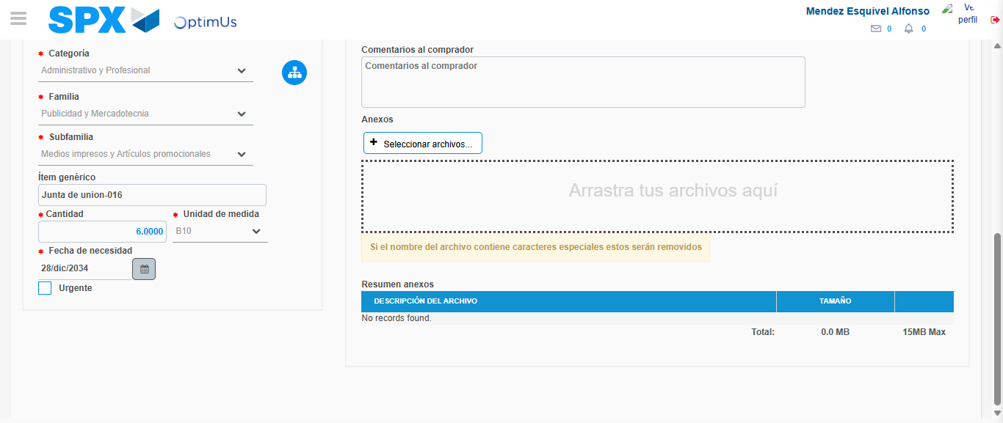Image file-name: QC_Testing-tc002_SPX_Dev5_Crear_Requisicion_Spot_Tipo_Cobro_Project-1784308246432

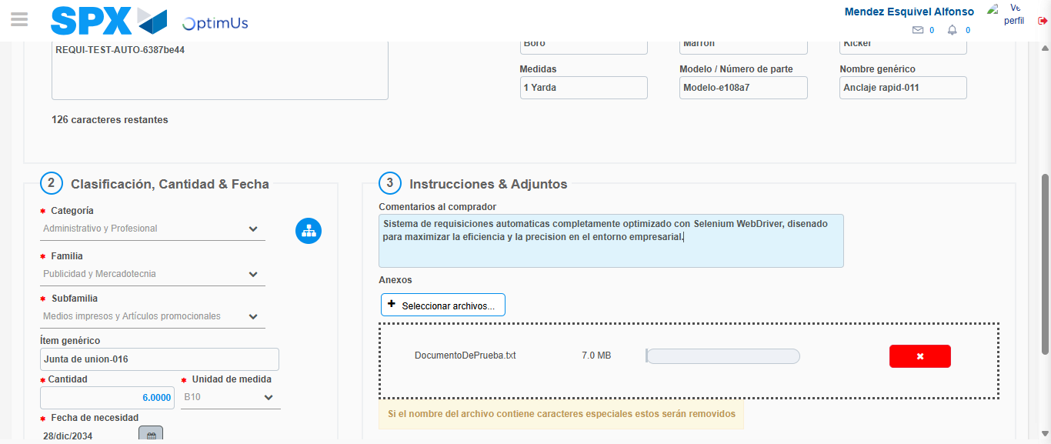Image file-name: QC_Testing-tc002_SPX_Dev5_Crear_Requisicion_Spot_Tipo_Cobro_Project-1784308247241

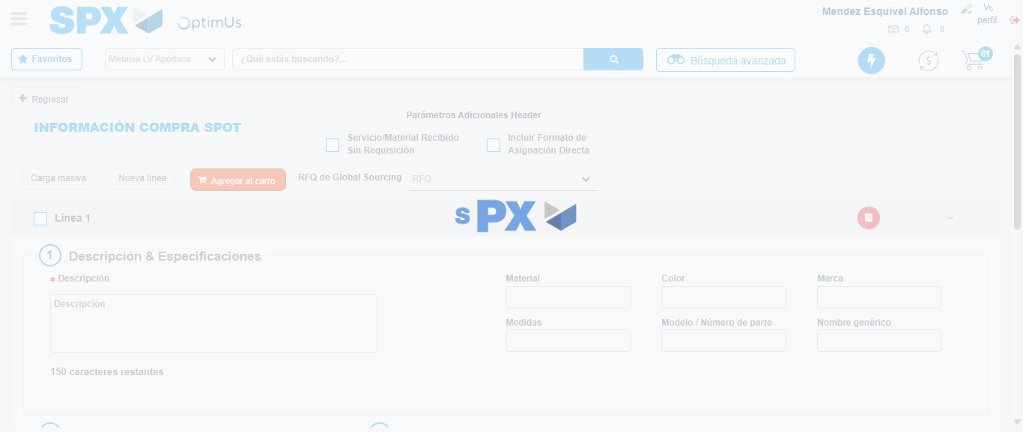Image file-name: QC_Testing-tc002_SPX_Dev5_Crear_Requisicion_Spot_Tipo_Cobro_Project-1784308252582

Step 7 - Return to Main Page SPX : Return to Main Page SPX
Image file-name: QC_Testing-tc002_SPX_Dev5_Crear_Requisicion_Spot_Tipo_Cobro_Project-1784308224220

Image file-name: QC_Testing-tc002_SPX_Dev5_Crear_Requisicion_Spot_Tipo_Cobro_Project-1784308226726

Image file-name: QC_Testing-tc002_SPX_Dev5_Crear_Requisicion_Spot_Tipo_Cobro_Project-1784308234708

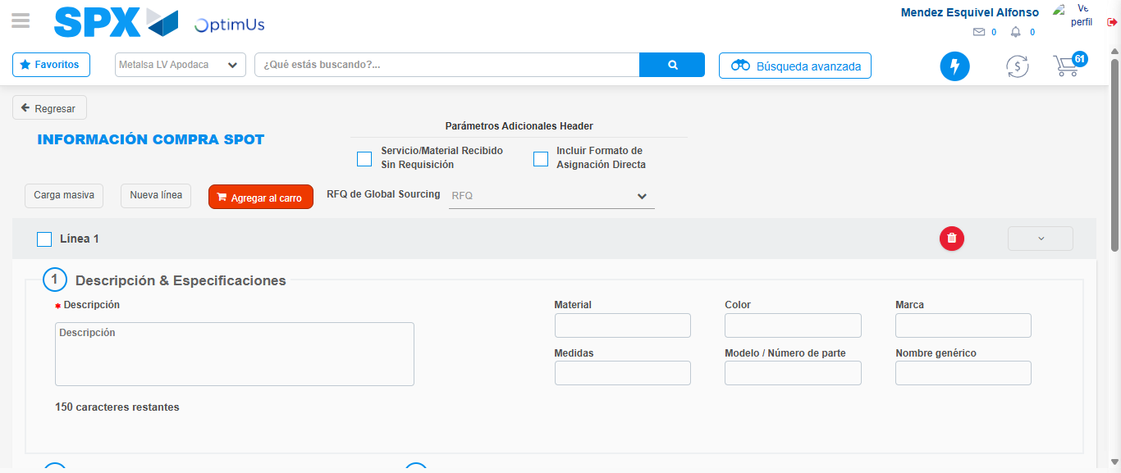Image file-name: QC_Testing-tc002_SPX_Dev5_Crear_Requisicion_Spot_Tipo_Cobro_Project-1784308254805

Image file-name: QC_Testing-tc002_SPX_Dev5_Crear_Requisicion_Spot_Tipo_Cobro_Project-1784308254988

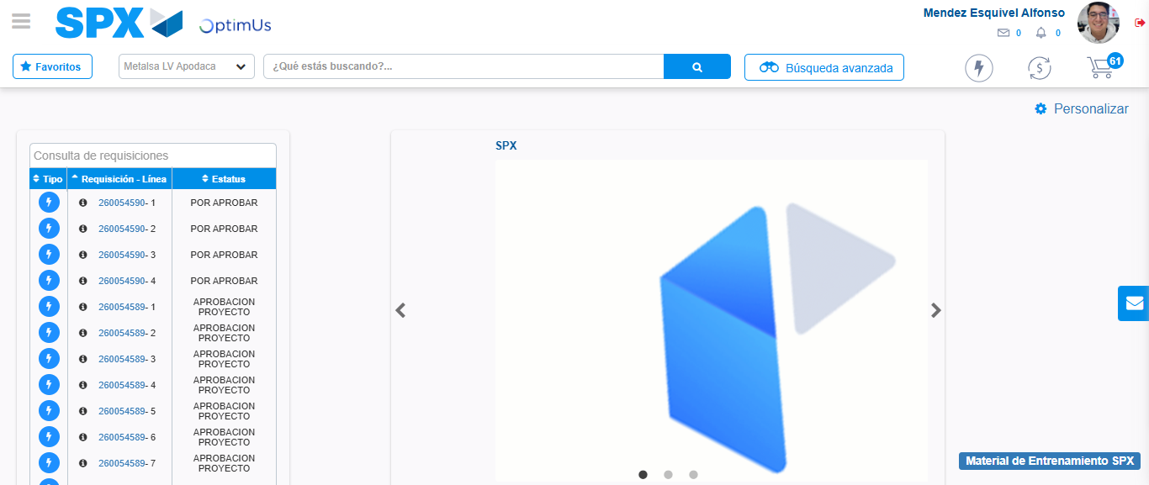Image file-name: QC_Testing-tc002_SPX_Dev5_Crear_Requisicion_Spot_Tipo_Cobro_Project-1784308276085

Step 8 - Log Out : Log Out SPX
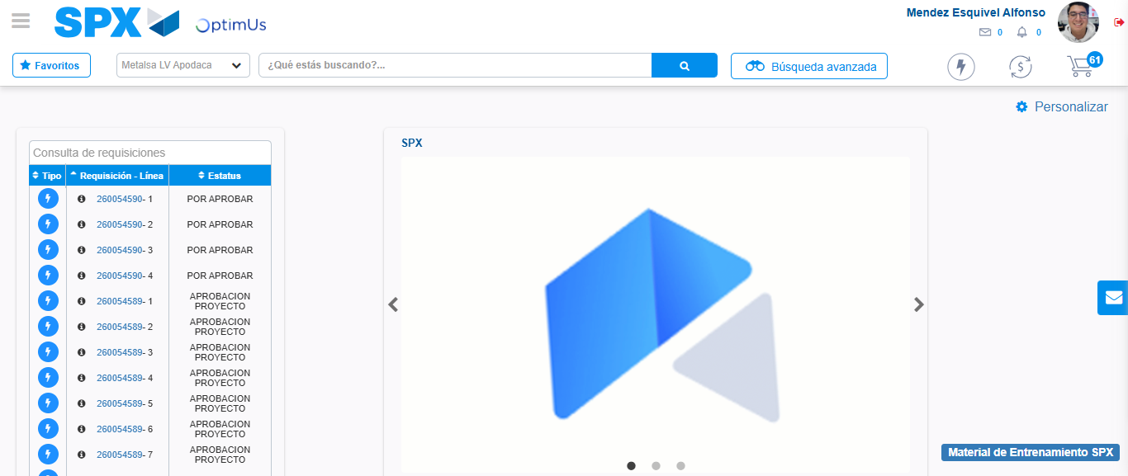Image file-name: QC_Testing-tc002_SPX_Dev5_Crear_Requisicion_Spot_Tipo_Cobro_Project-1784308276390

